

**Group Project report**

**Student Name Student Number**

BM Dulip. GAM/IT/2017/P/0001

B.A Asanka Madhawa GAM/IT/2017/P/0012

W.M.K Theeekshana GAM/IT/2017/P/0028

M.P.N.P Senarthna GAM/IT/2017/P/0035

P.M.D.S Amarasooriya GAM/IT/2017/P/0052

**Course :HNDIT Part Time**

**Supervisor Name :Ms. Mekala Jayawardhana**

**Title of Project : computer repair items stock maintain system**

Sri Lanka Institute of Advanced Technological Education

**Declaration**

The thesis is my original work and has not been submitted previously for a degree at this or any other university/institute.

To the best of my knowledge it does not contain any material published or written by another person, except as acknowledged in the text.

Students Name: Student ID: Signature

BM Dulip. GAM/IT/2017/P/0001 __________

B.A Asanka Madhawa GAM/IT/2017/P/0012 __________

W.M.K Theekshana GAM/IT/2017/P/0028 __________

M.P.N.P Senarthna GAM/IT/2017/P/0035 __________

P.M.D.S Amarasooriya GAM/IT/2017/P/0052 __________

Date: 14/10/2018

Page i

**Acknowledgement**

We would like to express my special appreciation and thanks to our supervisor Mrs. Mekala Jayawardhana for her continuing guidance, advice, and encouragement in our way to prepare this project. Her patience and tolerance towards us helped to finish this project and we would like to express our appreciation to her.

We would also like to all lecturers at Advanced Technology Institute Naiwala for their support, all of you have a true gift for teaching.

So much love and thanks to my parents for their belief, continuing understanding, and sacrifice in support of my writing.

Finally, appreciation to all our friends and classmates for their kindness and support and we would like to thank all those who helped me in numerous ways to make this project a success.

Page ii

**Abstract**

Information and Communication Technology is the most trending technology which influences most of the operations in the world.

* The system requires very less time factors
* The system will provide fast and efficient automated environment instead of slow and error prone manual system, thus reducing both time and man power spent in running the system.
* The system will have GUI interface and very less user-training is required to learn it
* The system will provide service to view various information for proper managerial decision making

People are inherently resistant to change, and computers have been known to facilitate change. As estimate should be made of how strong a reaction the user staff is likely to have toward the development of a computerized system. Therefore it is understandable that the introduction of a candidate system requires special efforts to educate and train the staff. The software that is being developed is user friendly and easy to learn. In this way, the developed software is truly efficient and can work on any circumstance, tradition, locals.

Page iii

**Table of Contents**

Declaration………………………………………………………………………………i

Acknowledgement……………………………………………………………………...ii

Abstract………………………………………………………………………….……..iii

Table of content………………………………………….…………………………….iv

List of figures……………………….………………………………………………….v

Abbreviations………………………………………………………………….………vi

1. Introduction
   1. Business process
   2. Existing system
   3. Problems and weaknesses
   4. Aims and objectives
   5. Benefits of the projects
   6. Scope of the projects
2. system analysis
3. system design
4. development
5. testing

Page iv

List of figures

3.1 ER Diagram

3.2 Use case diagram

3.3 Activity diagram User login

3.4 Activity diagram user registration

3.5 Main interface

3.6 System administrator login interface

3.7 User registration interface

3.8 Inventory holder login interface

3.9 item registration interface

3.10 Technician login interface

3.11 technician stock check interface

3.12 Technician requesion interface

3.13 Officer in-charge login page

3.14 officer in-charge authentication form

3.15 Inventory holder stock issue form

**Introduction**

Stock Management system is software which is widely used by retailers, shopkeepers, manufacturing units and other merchants across different businesses.

**1.1 Business process**

So now let me tell you how the system works. We will understand this with an example of a retailer selling items to its technician as an example.

Here the sales person will scan the bar code of each of the item you have picked up. Now the software will interpret the bar code of each of the item and match it with those available in the database of the system.

By this procedure the Manager can track the sales of the items from its workshop. The system now gives a clear picture to the manager about the total sales and items available in the stock. It tells him/her the quantities present on shelves or in warehouse.

So now the manager can decide that which items have sufficient stock or which items needs reordering.

The reordering of items is also provided by the Stock Management System. It has an interface to communicate with vendors providing the required goods.

Now let me tell you what happens when the reordered items reach the warehouse. The item is added into the warehouse by reading its bar code through a bar-code scanner and its quantity is updated into the system.

If any new item is ordered, then the details of the new product are added in the system. Its barcode and quantity is added in the system. This bar code stored in the system is matched at the time of billing to update the items in stock.

By this procedure the section in-charge can track the stock of the items from its hardware workshop. The system now gives a clear picture to the officer in-charge about the total items available in the stock. It tells him/her the quantities present on in warehouse.

So now the in-charge can decide that which items have sufficient stock or which items needs reordering.

The reordering of items is also provided by the Stock Management System. It has an interface to communicate with vendors providing the required goods.

Now let me tell you what happens when the reordered items reach the warehouse. The item is added into the warehouse by manual entry or reading its bar code through a bar-code scanner and its quantity is updated into the system.

If any new item is ordered, then the details of the new product are added in the system. Its barcode and quantity is added in the system. This bar code stored in the system is matched at the time of issuing to update the items in stock.

Steps

1. Tech control in-charge add IT spares or IT consumable items name, reference number, serial number and warranty expired date
2. Checked newly add stock item details by section in-charge
3. Issue some items for use add that details in the system and forward to section in-charge for confirmation
4. Checked issued items for daily used and ensure that procedure
5. Again and again rewind this steps

**1.2 Existing system**

Existing system is manual to keep transaction record of the inventory in the inventory. People still prefer to follow the manual method to keep the record. We have found that employees first of all record all information in there ledger.

**1.3 Problems and weaknesses**

They are using to keep the record of stock purchase, inventory, and issued. Following this method is very time consuming and tedious. It has many drawbacks as there may be mistakes while recording large data and this may disrupt the important transaction.

Suppose that a technician enters the store and ask for an item from the store. Then the tech controller in his UI chooses the sub UI for issuing and chooses the item code the technician asked. Note yet the technician has not decided the quantity of item he needs or asks for more items and the quantity for the first item he asked could get changed. Then consider another technician enters the store and asks for a particular quantity of the same item the previous technician asked from another inventory holder in the store. Then this tech controller also chooses the sub UI for issuing and chooses the item code the technician asked. Here a problem arises. As the first technician should be given the first priority here the second inventory holder cannot issue the item without the first technician is done choosing every items he needs, saved and being given the item he requested.

For the above problem that arose, here as soon as the first technician chooses the particular item, the program written logically lock the data for the above item. So even though the second technician asks for the same item, until the first technician is done with his purchase, the second inventory holder cannot see anything regarding this item. When the first technician is done his purchase the systems then unlock the data for the above item and then the second inventory holder can start the issuing process.

The above solution seems very fair to an eye, which sees that the first person to ask, should be given the first priority. But the above method could result long queues where people could get easily angry and frustrated. The second technician to ask for the same item the first technician asked takes sometimes. Time is wasted.

Suppose a technician enters the store and asks for a particular item in a particular quantity from a inventory holder. Then a second technician also enters the store and asks for the same item in a particular quantity from another inventory holder. In the previous method the second technician had to wait until the first technician is done with his whole purchase. But as a solution to this, as soon as after the first technician asked for the particular item in a particular quantity, when the tech controller enters what the technician asked and the quantity, before the first technician to choose other items and save the purchase and make the other technician wait, the program logically deletes the particular quantity of the item from the database the first technician asked. So the data of the particular item mentioned above is visible to the second inventory holder in a shorter period of time than the time period mentioned above. So this shortens even further the time for two technicians who ask for the same item.

Suppose a technician enters the store and asks for a particular item in a particular quantity. So if the program is written as mentioned in the solution 2, as soon as the inventory holder chooses item mentioned and the quantity mentioned, the quantity of the particular item available in the store is subtracted in the database according to the technician asked. Then suppose another technician enters the store and asks for the same item mentioned above in a bigger quantity. But as the quantity of the particular item available in the shop is subtracted as soon as the inventory holder enters what the first technician asked, the store could no longer issue the quantity of the particular item mentioned. If the first person continue his purchase, no problem. But suppose the first technician later says that he no longer need the item mentioned or he needs a lesser quantity of item, it cannot be undone and the chance to issue the item to the second technician may also get reduced. Financially this could result very heavily to a big store.

So as mentioned in the difficulty 3, it is quite not suitable to subtract the quantity of an item that is available in the store directly in the database. So as a solution to this we came up with an idea to introduce a static variable that is stored in the RAM not in the database. As soon as a technician asks for a quantity of a particular item, this static variable equalizes it value to the quantity available in the store. If the purchase is not yet done and a second technician enters the store and asks for the same item in a larger quantity, he is then shown remain of the item available as a static variable. Then the first technician saves the purchase and then the quantity of item available in the store is gets subtracted to the new one in the static variable and then the quantity in the database also decreases so the second technician cannot afford what he asked for. But suppose the first technician says that he no longer needs the item mentioned above or that he wants lesser than he mentioned before. Then the static variable shown to the second technician is become equal to the quantity available in the store or remains after the first technician changed the quantity he asked for.

**1.4 aims and objectives**

So, in this project we are trying to make inventory management system which will help employees to keep record of inventories is systematic way and help them produce report about the inventory or stock currently available in their department in automatic way to help then decision making about the stock.

* Ensure efficient and timely identification of vital corporate assets.
* To provide inventory system access to all necessary personnel.
* To provide full range of reports that will satisfy informational requirements
* To reduce labor of inventory management, centralize control and automation.
* Develop an automated system that will be able to record, store, retrieve and generate reports of inventory useful to management in decision making.

In today’s changing life style computer has become the most essential part of life. Most of the works being performed by the humans is now done by the computer is being used in each and every field now days. We are developing software for a stock exchange and  this software help in the stock exchange for their database maintaining and generating report corresponding to the data is done on the basis of as per requirement is given. So, we can say that it helps the management of stock exchange and give exact database management of company according to rules and regulation. It also help in maintain stock data and also display how many products are present in the stock and also gives the details of these products . This software also gives or stores each and every information about orders. This company uses a huge data base so for security of database we give the facility of backup and also recovery as per when company need it takes backup on floppy or on hard disk.

**1.5 benefits of the project**

* Increases productivity and efficiency.
* Creates a more organized warehouse.
* Helps save time and money.
* Improves accuracy of inventory orders.
* Keep technicians coming back for more.

**1.6 scopes of the project**

The scope of an inventory system defines which needs it addresses, including valuing the inventory, measuring the change in inventory and planning for future inventory levels. The value of the inventory at the end of each period provides a basis for financial reporting on the balance sheet. Measuring the change in inventory allows the company to determine the cost of inventory sold during the period. Together, inventory values and level changes allow the company to plan for future inventory needs.

**2 System analysis**

Stakeholder Analysis is an important technique for stakeholder identification and analyzing their needs. First, identify the important stakeholders who affect the project and their interest. Accordingly, the following stakeholders are engaged with the inventory management system.

1. Inventory Holder
2. Technician
3. Officer in-charge

2.1 Need Analysis

Before designing inventory management system App, a need analysis should be conducted to determine whether training is required to fill a gap between inventory holders and technicians with application.

Need Interviewed the patient who are using the android application.

2.1.1 Objectives of Need Analysis

i) Find out the problem of patients with app usage.

ii) Find out the problem of doctors with app usage.

1. Propose the solution

iv) Pinpoint areas of improvements or concerns that need to be addressed into online app

2.1.2 Target Audience

The target audience for this needs assessment can be separated into two categories: Inventory holders and technician.

2.1.3 Sampling Procedure

The focus group of this project is the doctors and patient who have use the android application. Therefore, it is important to identify their needs properly.

2.1.4 Data Collection Methods

Interviews

The individual who does decision making and conduct doctors and patients know the practical situation and the real-world issues take place. Therefore, it is better to conduct interviews with them as a variety of perspectives can be obtained as conversations are always open-ended and the questions can be clarified to the respondent. An interview was conducted with the doctors and patients to assess the treating situations.

2.1.5 Method of Data Analysis

The data which are collected from the above methods are analyzed. Descriptive method is used to analyze collected data. The data can be categorized in different ways. (Quantitative data and qualitative data, functional requirements and non-functional requirements etc...) The interview reports are also evaluated to identify functional and non-functional data / requirements.

2.2 Learner Analysis

It is important to study the users who use an android application. Therefore, the application to be effective and it must be interesting to the targeted audience.

There are many factors that affect how a user uses from a technical environment. Those are measured using.

1. Cognitive abilities of the user

2. Previous experiences of the user

3. Motivation

4. Personal app using style

5. Clarity of the message

2.3 Performance Analysis

This determines the exact app of the performance deficit that is preventing a user from achieving the objectives of the course and then identifying the performance required to achieve the objectives.

To build the app initiative, the designers have identified the (gap) correct performance– the difference between the actual or present performance and the desired or the best possible performance.

Environmental Analysis

Environmental analysis is important when considering the technical environment and its support systems.

**2.4 Requirement analysis**

**FUNCTIONAL REQUIREMENTS**

The System aims at providing an efficient interface to the user for managing of inventory; it shall also provide the user varied options for managing the inventory through various functions at hand. The ingredient levels are continuously monitored based on their usage and are checked for the threshold levels in the inventory and accordingly the user is alerted about low levels of certain spares. The design is such that the user does not have to manually update the inventory every time, the System does if for the user.

The System calculates and predicts the amount of usage for specific set days that are pre-set by the user (admin) it also alerts the user of an impending action to order IT spares before the specific day set by the user. Therefore the user never has to worry about manually calculating the estimated usage of the equipment’s as the System does it for the user. The simple interface of the System has functions like adding new items, edit or updating the items.

* System shall be able to **register** IT spares and IT consumable items with item code, and item name
* System shall be able to **update** details of IT spares and consumable items
* System shall be able to **remove** of IT spares and consumable items
* System shall be able to **categories** IT spares
* System shall be able to search spares by the item **reference no**, item **name** and **serial no**
* System shall be able to search **main stock available** in hand by item number,
* System shall be able to search some **stock nil** items
* System shall be able to search **reorder level** limit for IT spares
* System shall be able to generate **daily**, **weekly**, **monthly** stock balance report of all stock balance, category wise balance
* User requesting process and approval process
  + User levels
    - Officer i/c
    - Stock controller (SNCO I/C)
    - Technician

**NONFUNCTIONAL REQUIREMENT**

* **Usability**
* The system must be easy to use by both officer in-charge and section in-charge such that they do not need to read an extensive amount of manuals.
* The system must be quickly accessible by both officer in-charge and section in-charge.
* The system must be intuitive and simple in the way it displays all relevant data and relationships.
* The menus of the system must be easily navigable by the users with buttons that are easy to understand.
* **Reliability**
* The System must give accurate inventory status to the user continuously. Any inaccuracies are taken care by the regular confirming of the actual levels with the levels displayed in the system.
* The System must successfully add any spares and consumable items occasions given by the user and provide estimations and inventory status in relevance with the newly updated entities.
* **Security**
* System can be able to change users password any time
* System can be able to password show newer be viewable
* The system must provide a password enabled login to the user to avoid any foreign entity changing the data in the system.
* The system should not update the data in any database for any failed processes.
* **Performance**
* The system must not lag, because the workers using it don’t have down-time to wait for it to complete an action.
* The system must complete updating the databases, adding of spares successfully every time the user requests such a process.
* All the functions of the system must be available to the user every time the system is turned on.
* The calculations performed by the system must comply according to the norms set by the user and should not vary unless explicitly changed by the user.
* **Supportability**
* The software is designed such that it works even on systems having the minimum configuration.
* The system is adaptable even if additional plugins or modules are added at a later point.
* The data can be exported to the officer so as to make the system more portable.
* **Interfacing**
* The system must offer an easy and simple way of viewing the current inventory.
* The system must be able to display the relationships between spares in an intuitive manner.

**System Specification**

* Visual Studio 2010
* SQL Server 2012
* Laptop Computer

3 System Design

3.1 ERD

Entity Relationship (ER) diagram represents the system database architecture and its relationship with each entity. ER diagram will make the system run smoothly and allow performing faster. It speeds up data retrieval and data saving.

Entity Diagram with Attributes.

Entity Relationship Diagram (ERD) is the graphical representation of the entities interrelationship in the database. ERD uses basic constructs such as entities, relationship and attributes.

An entity is an object with a physical existence, a relationship shows how the data is shared between entities and attributes are the properties used to describe each entity. An entity will have a value for each of its attributes. The attribute values that describe each entity become a major part of the data stored in the database. Below shows the ER diagram of the system and entities and their attributes.

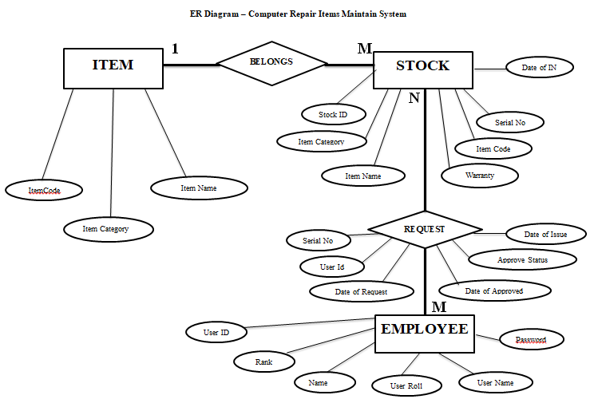

Figure 3.1 ED diagram

3.2 Use case diagram

When the flow of events is linear, a textual description of behavior is often sufficient to capture the system behavior in the use case diagram. Activities diagram provide a visual documenting sequence of task making up a single activity in the use case. They are especially useful for activities governed by conditional logic, and flow of event running concurrently.

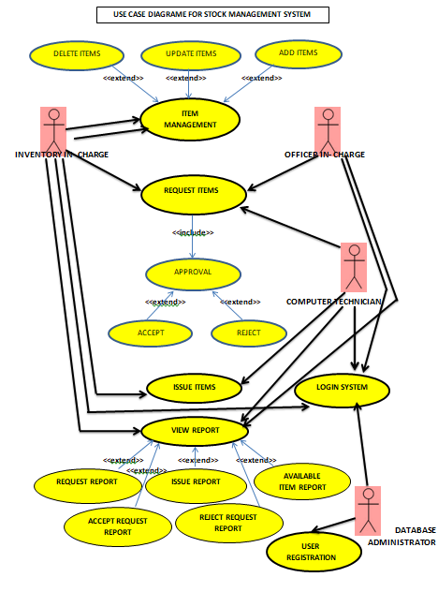Use case diagram describes the basic system functionality with textual use cases, and user activity diagrams for a visual representation of the corresponding sequence of task or flow of information.

Figure 3.2 Use case diagram

3.3 Activity diagram

Activity diagram is basically a flowchart to represent the flow from one activity to another activity in the use case diagram. These activities can be described as an operation of the system.

The control flow is drawn from one operation to another in the system. Activity diagrams capture the dynamic behavior of the system. Activity diagram can describe each use case in the system. Activity diagrams are not only used for visualizing the dynamic picture of a system, but they are also used to construct the executable system by using forward engineering techniques and reverse engineering techniques

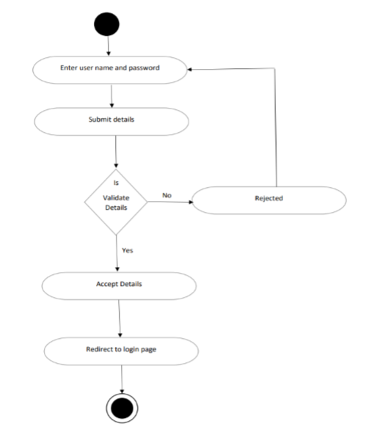

Figure 3.3 Activity Diagram user login

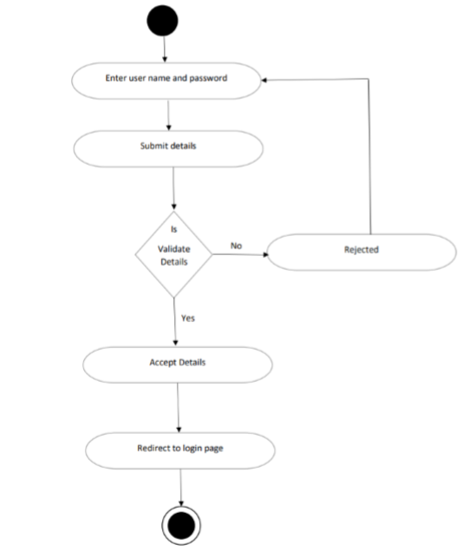

Figure 3.4 Activity Diagram user registration

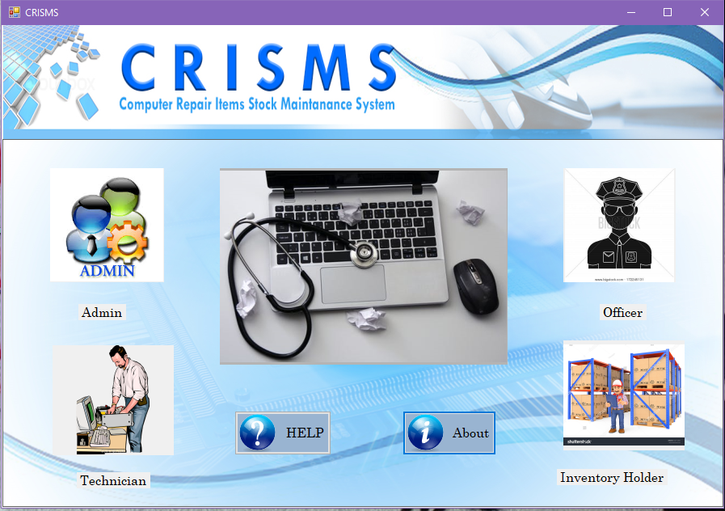

**MAIN VIEW**

Figure 3.5 main interface

**SYSTEM ADMINISTRATOR LOGIN INTERFACE**

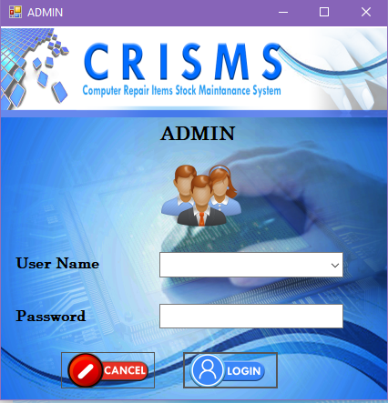

Figure 3.6 system admin

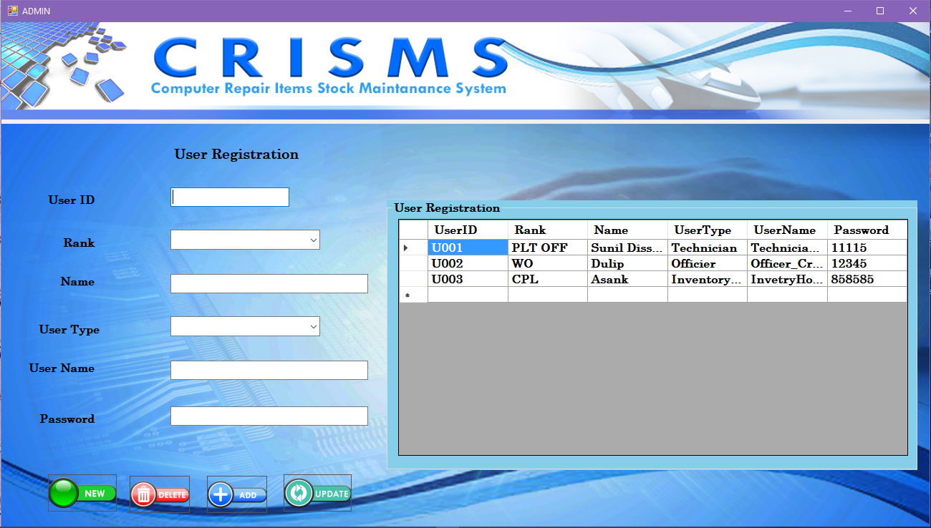

**USER REGISTRATION**

Figure 3.7 user registration

**INVENTORY HOLDER LOGIN INTERFACE**

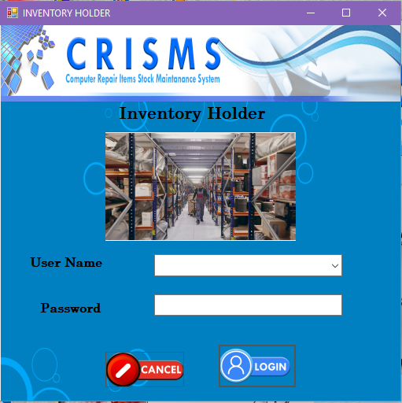

Figure 3.8 Inventory Holder login interface

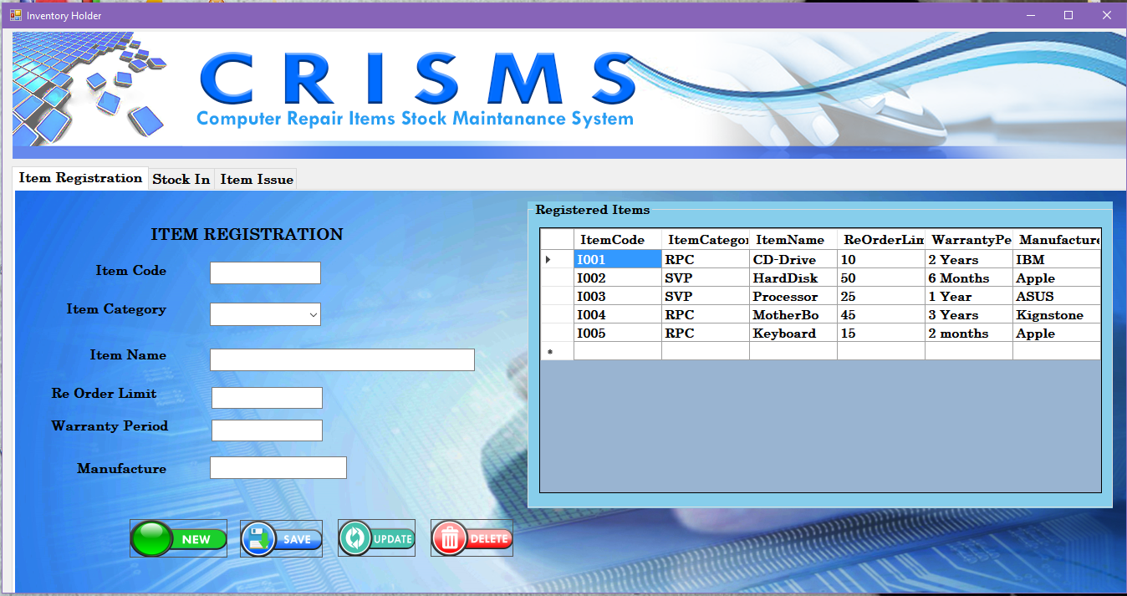

**ITEMS REGISTRATION**

Figure 3.9 item registration interface

**STOCK IN REGISTER**

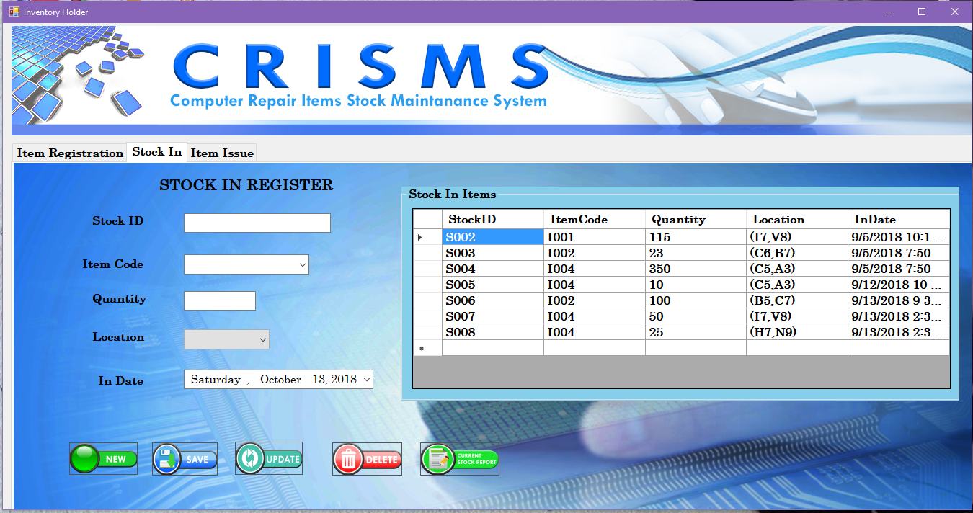

Figure 3.10 Item stock in interface

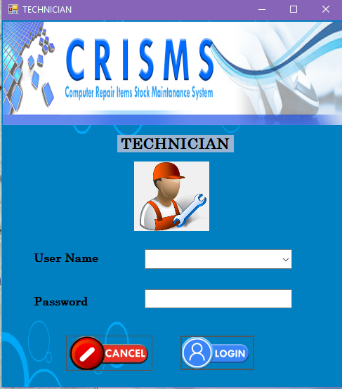

**TECHNICIAN LOGIN INTERFACE**

Figure 3.11 Technician login interface

**ITEM REQUITION**

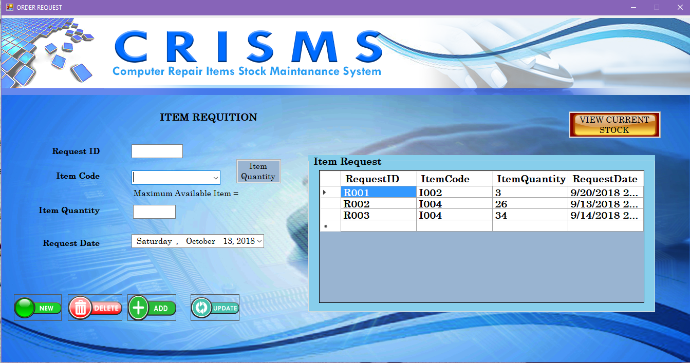

Figure 3.12 technician item requition interface

**CHECK AVAILABLE STOCK**

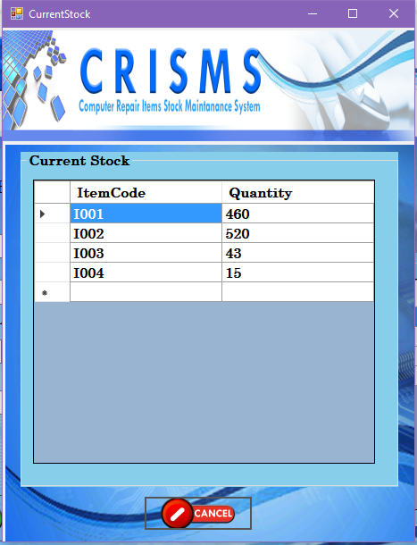

Figure 3.13 stock check by technician

**OFFICER IN-CHARGE LOGIN INTERFACE**

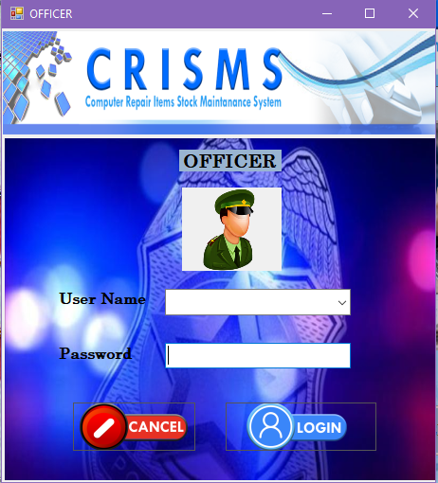

Figure 3.14 officer in-charge system login

**AUTHENTICATION PROCESS**

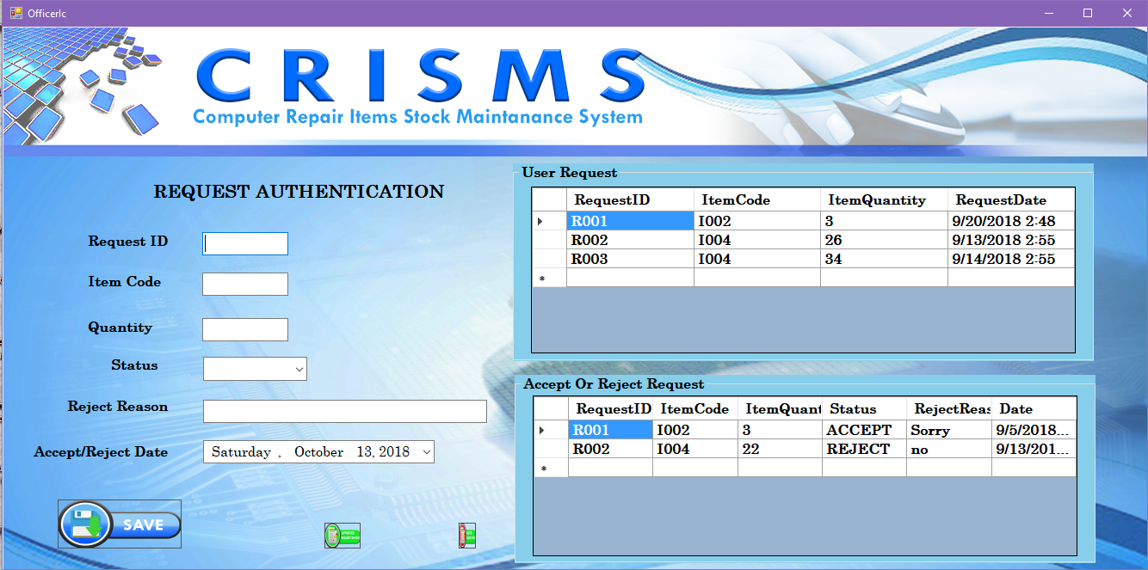

Figure 3.15 officer in-charge authentication

**INVENTORY HOLDER ITEM ISSUE**

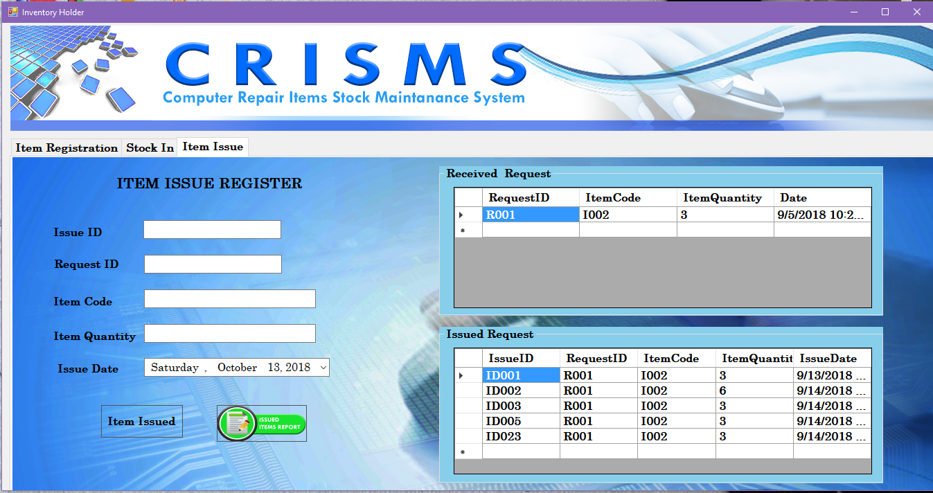

Figure 3.1 inventory holder item issued

**Conclusion**

The database will enable the update, retrieval, deletion, and generation of Inventory reports accordingly. The complete and appropriate implementation of this Inventory management system on stock items will yield signiﬁcant advantages to the organization.

The application delegates some administrative work to the patients by allowing them to manage their own appointment and personal profiles. Time will not be wasted on converting paper-based appointment record into electronic-based.

The system further helps to reduce healthcare personnel workload by allowing them to generate medical reports easily. They could now maximize their competence and allocate more time to maximize service quality.

**References**

https://www.fishbowlinventory.com/inventory-management

https://www.wikipedia.org

https://www.youtube.com/watch?v=xjsUiLrgIks

http://www.programsformca.com/2012/03/uml-diagrams-for-stock-maintenance.html

https://www.javatpoint.com/RMI

https://docs.oracle.com/javase/7/docs/technotes/guides/rmi/hello/hello-world.html

https://en.wikibooks.org/wiki/Java_Programming/Remote_Method_Invocation